Inventory Management System

[Report]

By

Talha Saleem, Owais Uddin Gilani & Owais Karni

[B13101154], [B13101107] & [B13101106]

Course Title: Internet Application Development

Teacher’s Name: Sir Usama Ayaz

Table of Contents

Project Requirements 2

Entity Relationship Diagram 2

Data Flow Diagram 3

Architecture Diagram 4

UML Case Diagram 4

Instructions To deploy 5

Git Repositories 5

Source Code Documentation 5

API Documentation 5

Members Contribution 6

# Project Requirements

* Company Management
* Branch Management
* User Management
* Products Management
* Sales Order Management
* Accounts Management
* Invoices Management

# Entity Relationship Diagram

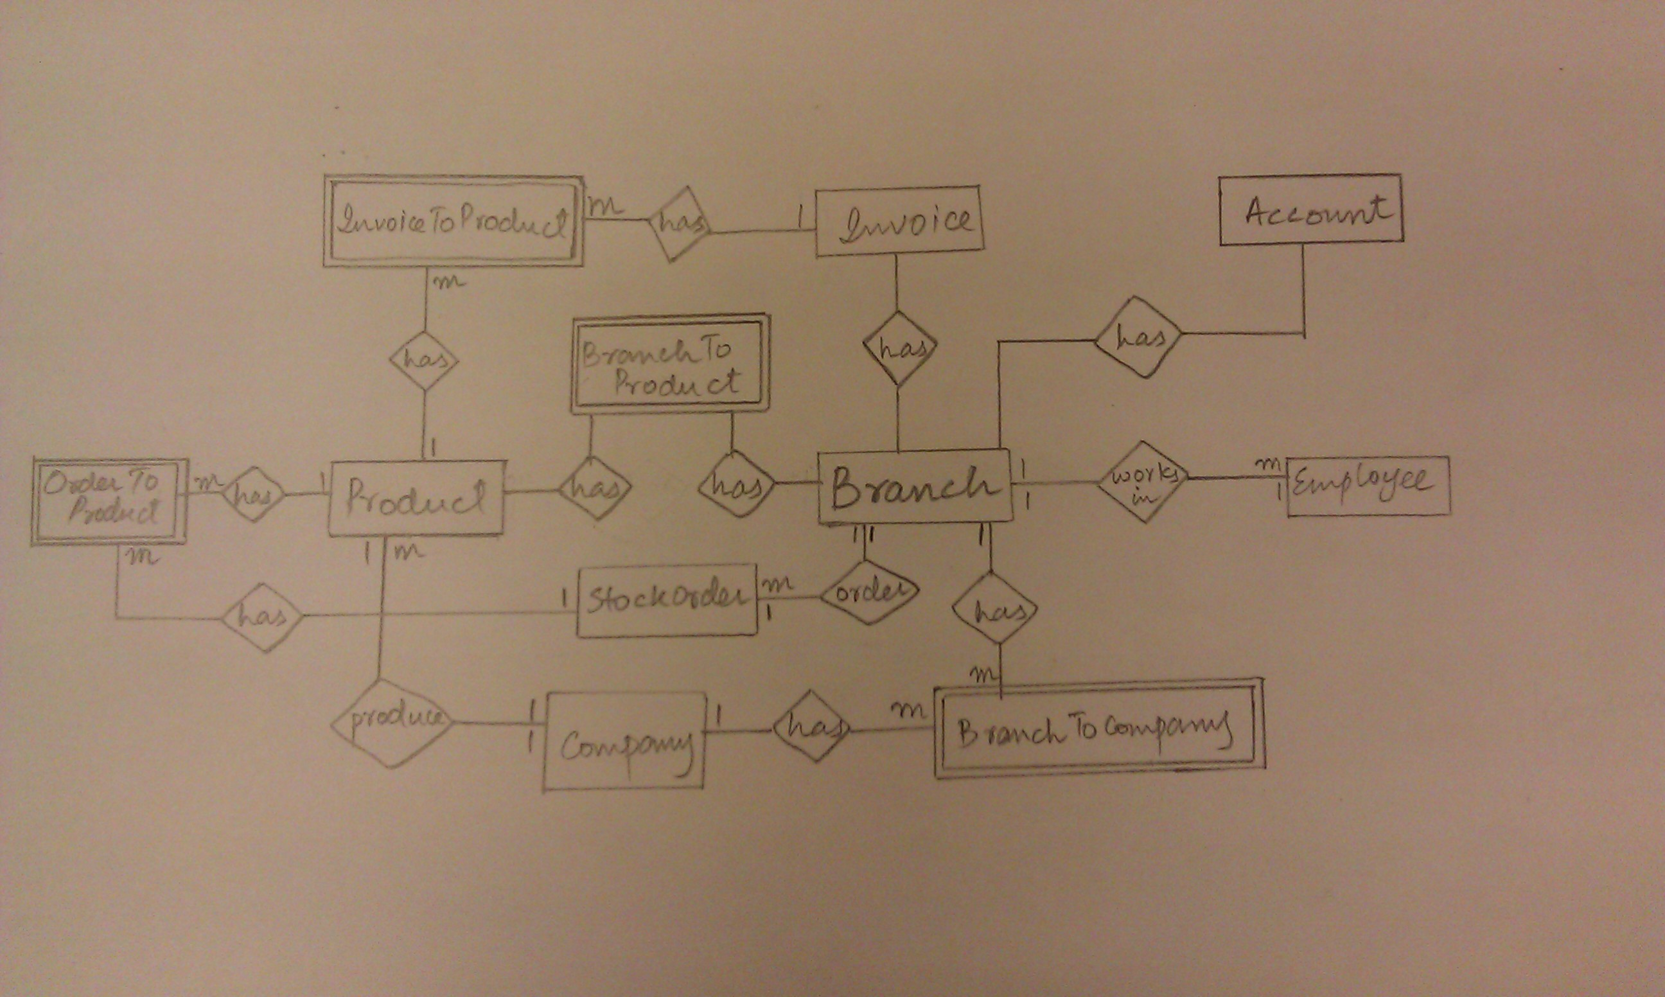

# Data Flow Diagram

1. Super User

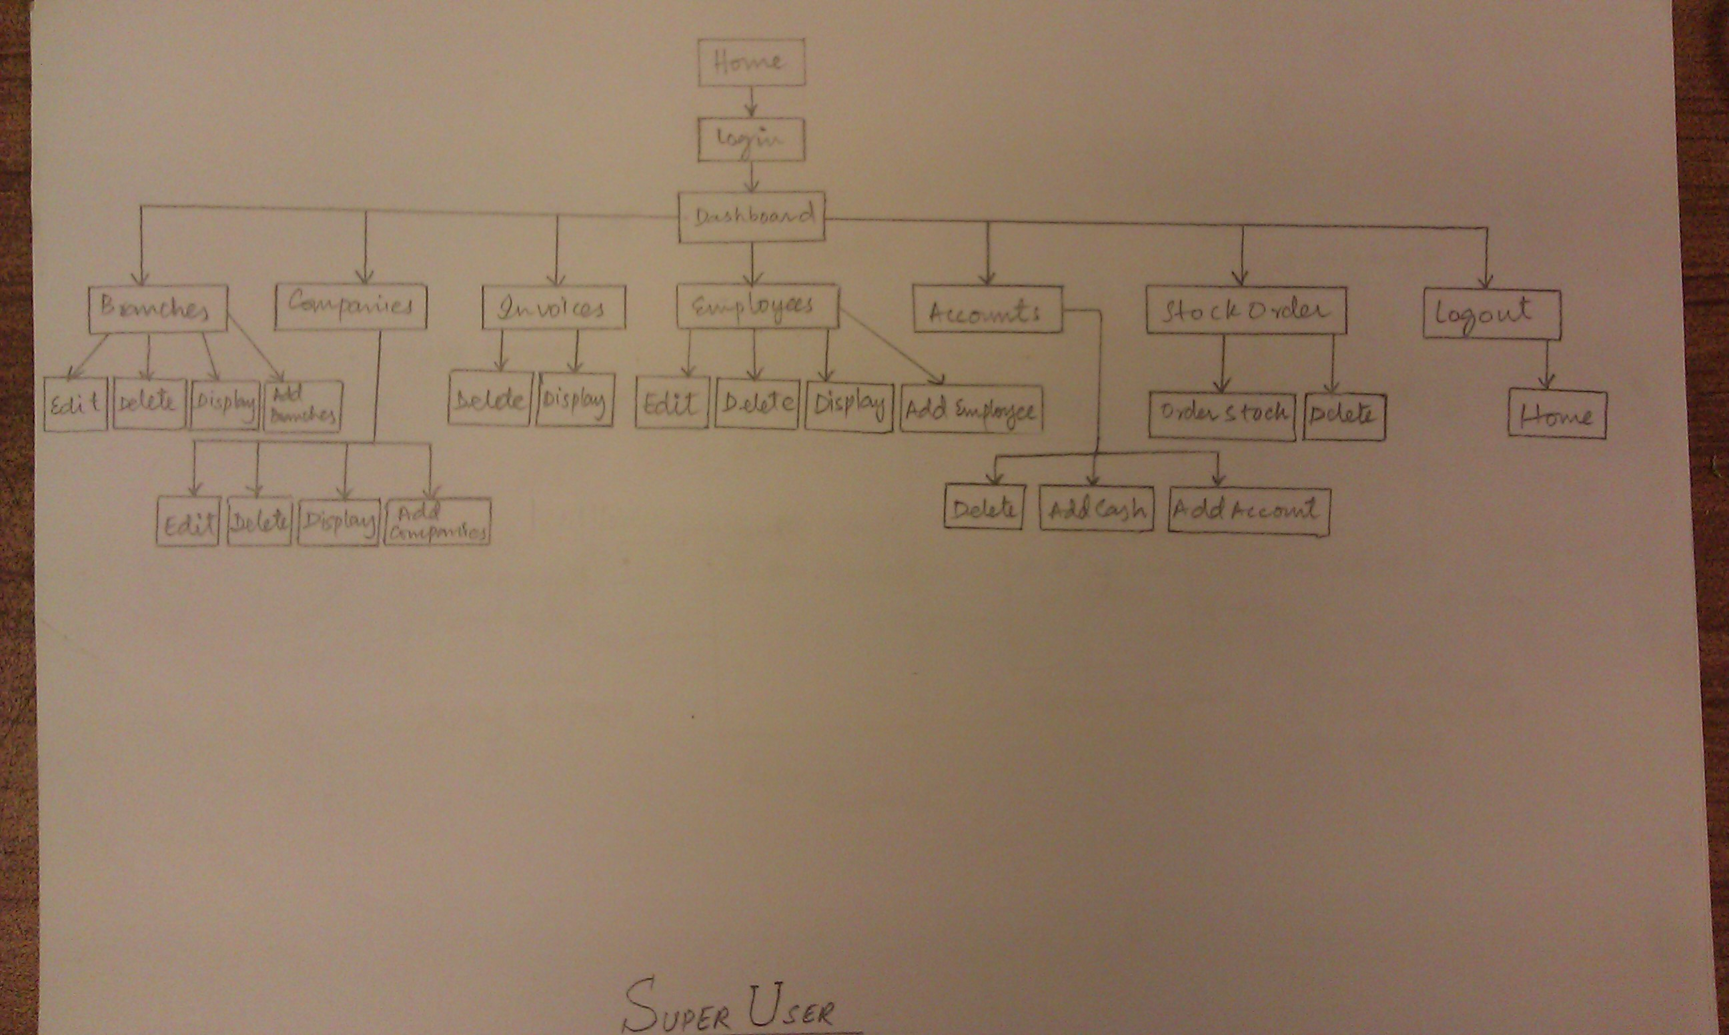

1. Manager & Employee

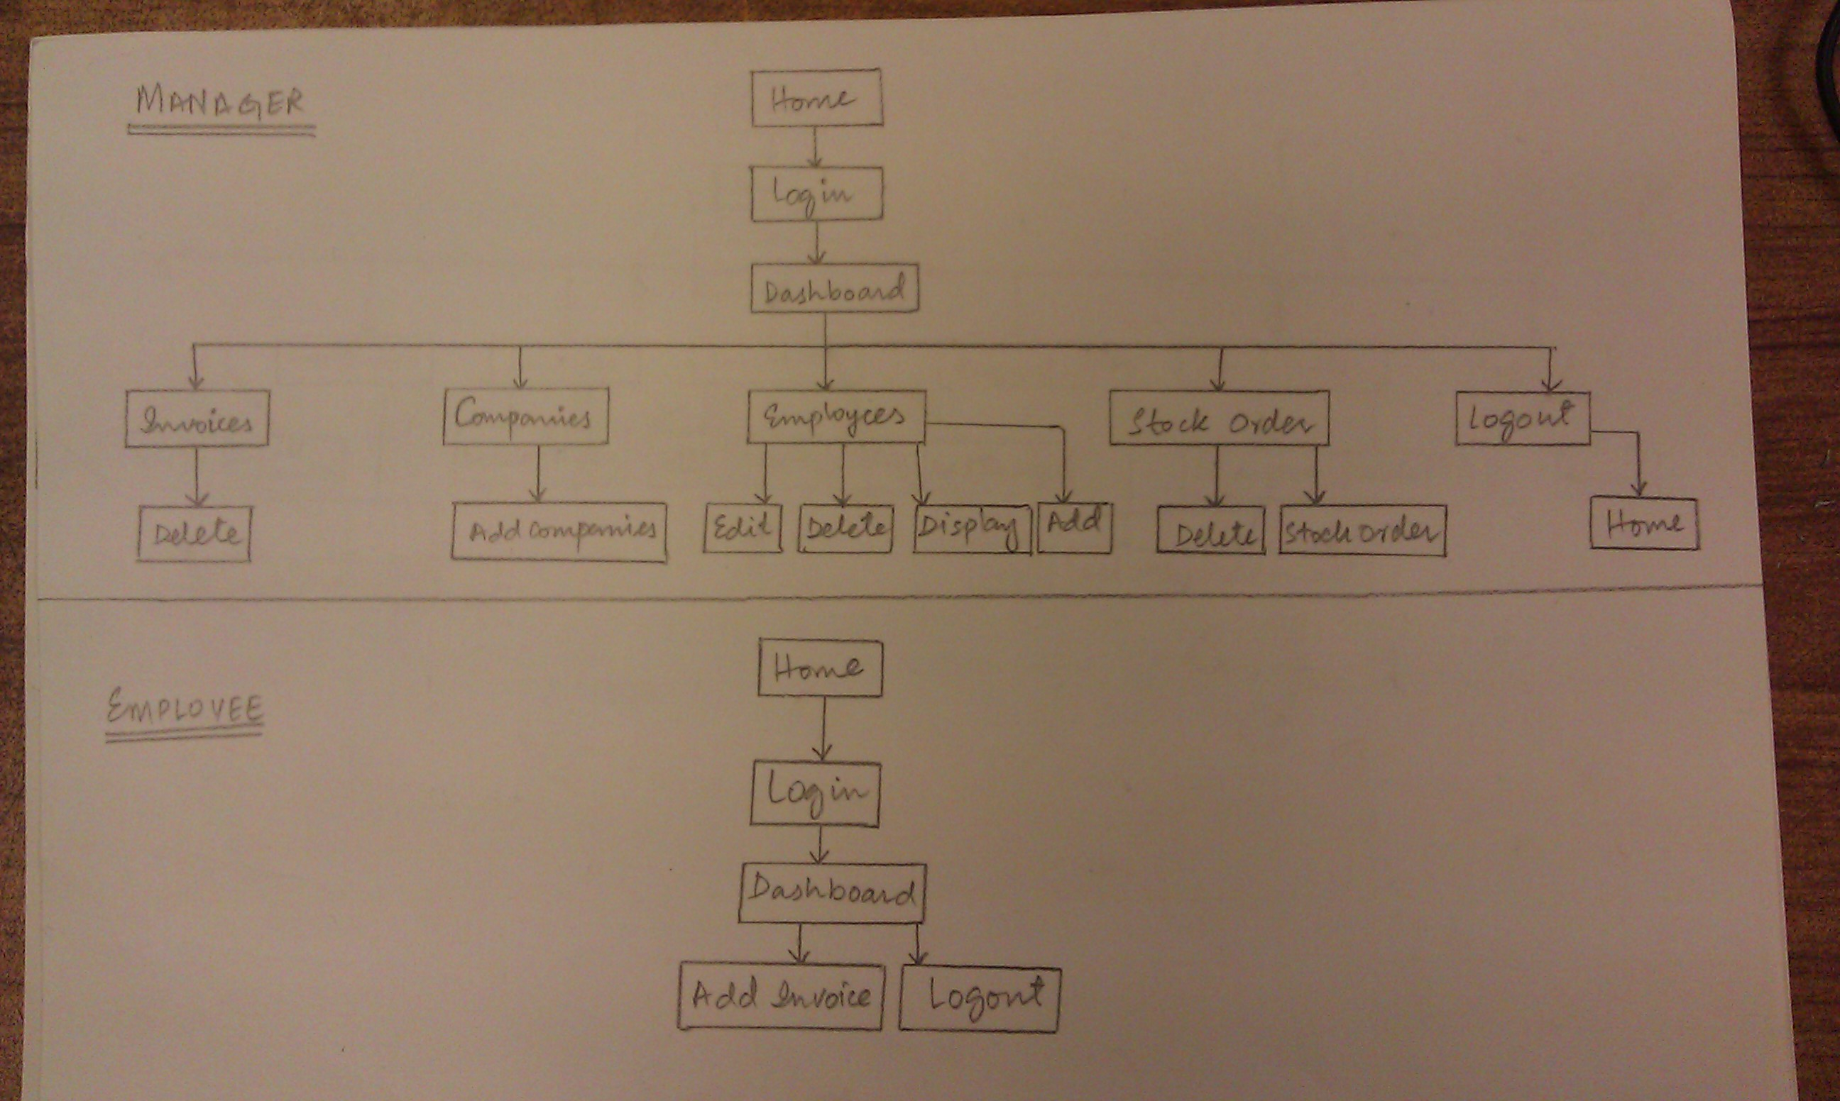

# Architecture Diagram

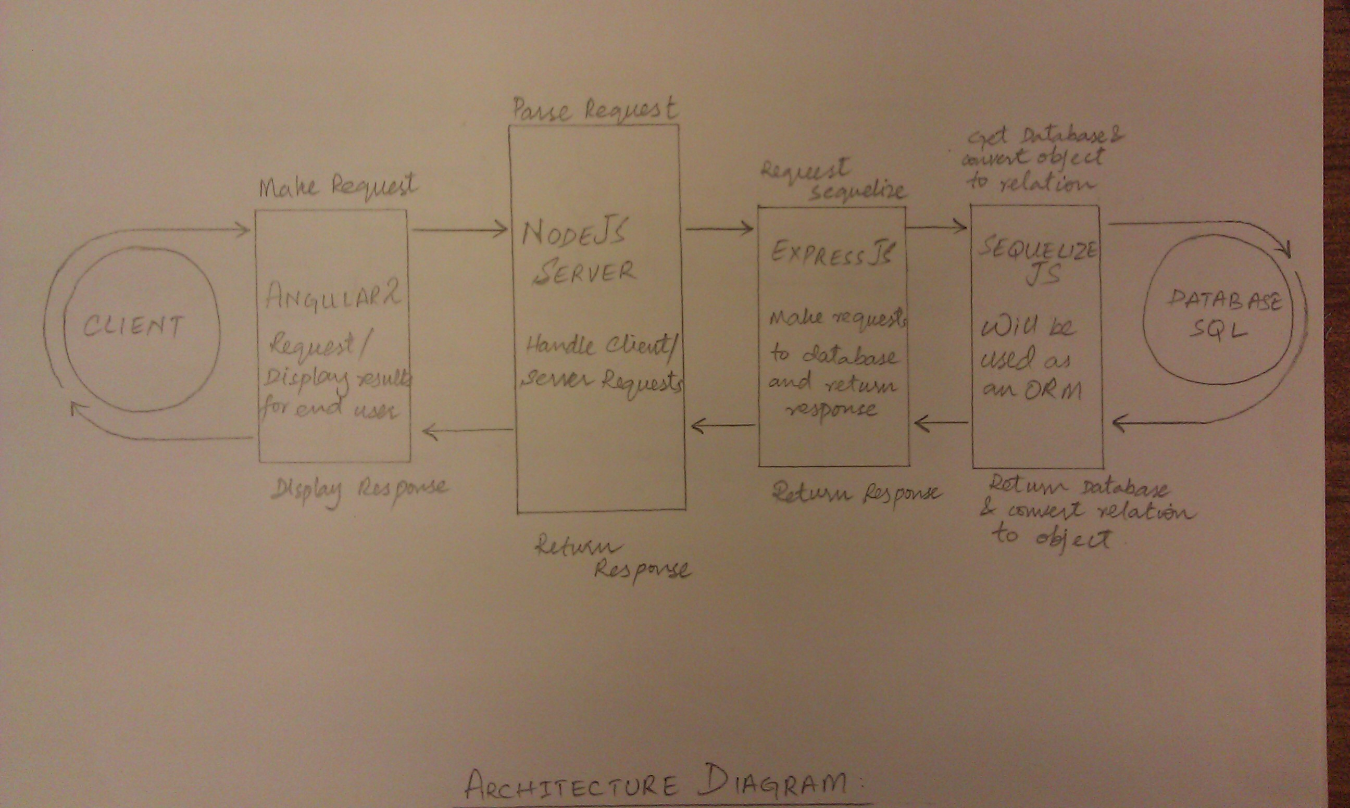

# UML Case Diagram

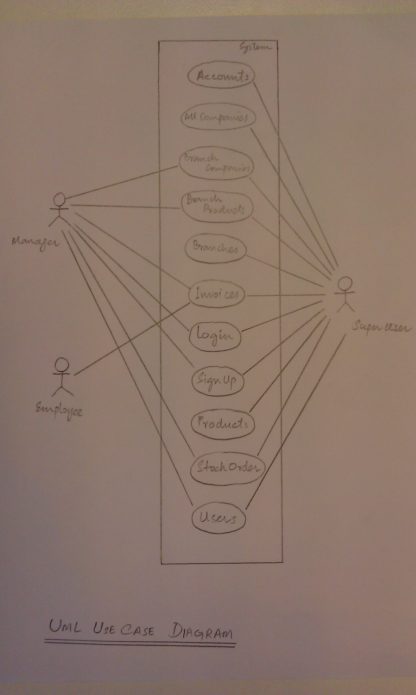

# Instructions To deploy

To run this project a user must download the given repos from the provided links in the next heading. Following technologies and their dependencies must be installed on the user’s computer.

* TypeScript Compiler
* NodeJS
* Node Package Manager (NPM)
* Nodemon
* Angular-CLI
* Angular2
* Express JS
* Express-JWT
* Authguard
* MySQL
* Sequelize JS
* Sequelize-CLI
* Bootstrap3
* Modular Form Validator (MDF)

**For Client Side**

After downloading the client side code run the following commands.

* $ npm install
* $ ng serve

**For Server Side**

After downloading the server side code, create a database “inventory” inside MySQL and run the following commands.

* Login with your MySQL credentials
* CREATE DATABASE inventory;

In the terminal of server side code run the following commands.

* $ npm install
* $ sequelize db:migrate –env development
* $ sequelize db:seed:all
* $ nodemon

Also note that before running these commands head over to config/config.json file and change the user name, password as of your MySQL (for Windows users also add [“port”:”<port-number>”])

# Git Repositories

Client Side Repo

[git@bitbucket.org:inventory-iad-project-2017/inventory-angular2-clientside.git](mailto:git@bitbucket.org:inventory-iad-project-2017/inventory-angular2-clientside.git)

Server Side Repo

[git@bitbucket.org:talhasaleem/inventory_expressjs_serverside.git](mailto:git@bitbucket.org:talhasaleem/inventory_expressjs_serverside.git)

# Source COde Documentation

Provided with the code.

# API Documentation

Attached with this report.

# Members Contribution

* Talha Saleem [Server Side Code]
* Owais Uddin Gilani [Client Side Code]
* Owais Karni [Documentation, Front End and Back End]